***Abstract***

**This GIS research project provides spatial information on how clear-cut logging in Humboldt County and Del Norte County is threatening the Humboldt Marten, *Martes caurina humboltensis*. The Humboldt Marten, sub-species of the American Marten,, is historically found exclusively in Humboldt County and it is registered as a “species of concern,” in the State of California and does not have an official “endangered species” status. As unsustainable timber harvesting continues within Marten’s population range, this beautiful Marten species faces population size threats.This research project is in support of the Environmental Protection Information Center (EPIC) located in Arcata, Ca. The main focus in the analysis is looking at the overlapping intersections of illegal Timber Harvest Plans in between the Region of Interest located in between Northern Humboldt County and Southern Humboldt County. This region of interest is important for Habitat Population for Humboldt Marten because they depend on old growth forest that contain Conifer and Mixed-Conifer Canopy cover types. The results are there is more Mixed-Conifer canopy cover type being harvested than strictly Conifer forest.**

**Key Words: Humboldt Marten, Humboldt Marten Extend Population, Timber Harvest Plans, Unsustainable Timber Harvesting, Conifer Forest, Mixed Conifer Forest.**

**Table of Contents:**

**Title Page-------------------------------------------------------------------------------------1**

**Abstract------------------------------------------------------------------------------------------------2 Table of Contents-------------------------------------------------------------------------------------3 Introduction-------------------------------------------------------------------------------------------4 Methods------------------------------------------------------------------------------------------------6 Results-------------------------------------------------------------------------------------------------**

**Figure 1:-----------------------------------------------------------------------------------------------8**

**(add any Tables to Contents)**

**Conclusion-------------------------------------------------------------------------------------------10 Acknowledgements---------------------------------------------------------------------------------10 References-------------------------------------------------------------------------------------------11 Appendices------------------------------------------------------------------------------------------12**

**Introduction**

**The Humboldt Marten, *Martes caurina humboltensis*, is a weasels sub-species of the American Marten. This subspecies is exclusively found only in Humboldt County, located in Northern California, however, it can also be found in along the coast in Oregon and Washington. The Humboldt Marten is currently registered as a species of concern in the State of California and does not have any special status under the Endangered Species Act (No Author, 2010). As timber harvesting continues within or near the Humboldt Marten’s historical home range, this species faces more threats due to private industrial harvesting (No Author, 2010). The Environmental Protection Information Center also known as EPIC, located in Arcata, California is a non-profit organization that focuses on being science-based protection and restoration of Northwest California’s Forests. EPIC must ensure that state and federal agencies follow their mandate to uphold environmental laws and protect endangered species. These private timber industries are mandated by the federal to show proof of sustainable Timber Harvest Plans each year. In some areas in California, where there is an old growth forest with large amounts of conifer and mixed conifer cover-types, timber harvesting is not allowed due to the habitat dependency on old growth forest. However, the rules do not apply the same on private property. For instance the according to Hutchinson & Livingston (2018) suggest “The forest harvest trends in the Pacific Northwest have generally been shaped by land ownership. Timber harvest rates have historically been higher on private industrial lands than on private non–industrial or public land. By understanding general timber management regimes of different land ownerships informs our understanding of the potential to retain or develop marten habitat”(Pg.1). Ownership of land is understandable, this paper doesn’t focus on the rights to land ownership instead it's focuses on the damaged timber may cause onto the Humboldt Marten’s population range within the old growth canopy forest.**

**This research paper is devoted to conducting an analysis that can help aim for forest protection within the Humboldt Marten population range that overlap with private timber harvest plans in Humboldt and Del Norte County. I am a geospatial analyst intern with the EPIC. EPIC is committed to re-evaluating the listing for the Humboldt Marten (*Martes caurina humboltensis).* To have a threatened or endangered listing under the Endangered Species Act, evidence of how timber harvesting has threatened the Humboldt Marten population within its historic home range is necessary. Geographic Information Systems (GIS) can be used to track and analyze the spatial trends of recent private illegal timber harvesting conifer and mixed conifer cover types that are located within the marten’s population area located in Humboldt County and Del Norte County. This area is significant because of the marten’s dependency on old growth forest canopy cover. According to the Notice of Receipt of the Petition, published in 2015, states “Humboldt Martens are generally found in closed-canopy, old-growth forests with a complex structure on or near the ground” (No Author). Thus further indicating EPIC’s interest in protecting this area shown in Figure 1. According to Rob DiPerna, Environmental Sustainability Advocate at EPIC, states this area would protect many martens along with other animals and ecosystems. The goal of this analysis is to calculate the amount of timber harvest in acres and also analyze what type of timber is being harvest within the Humboldt Marten’s population range.**

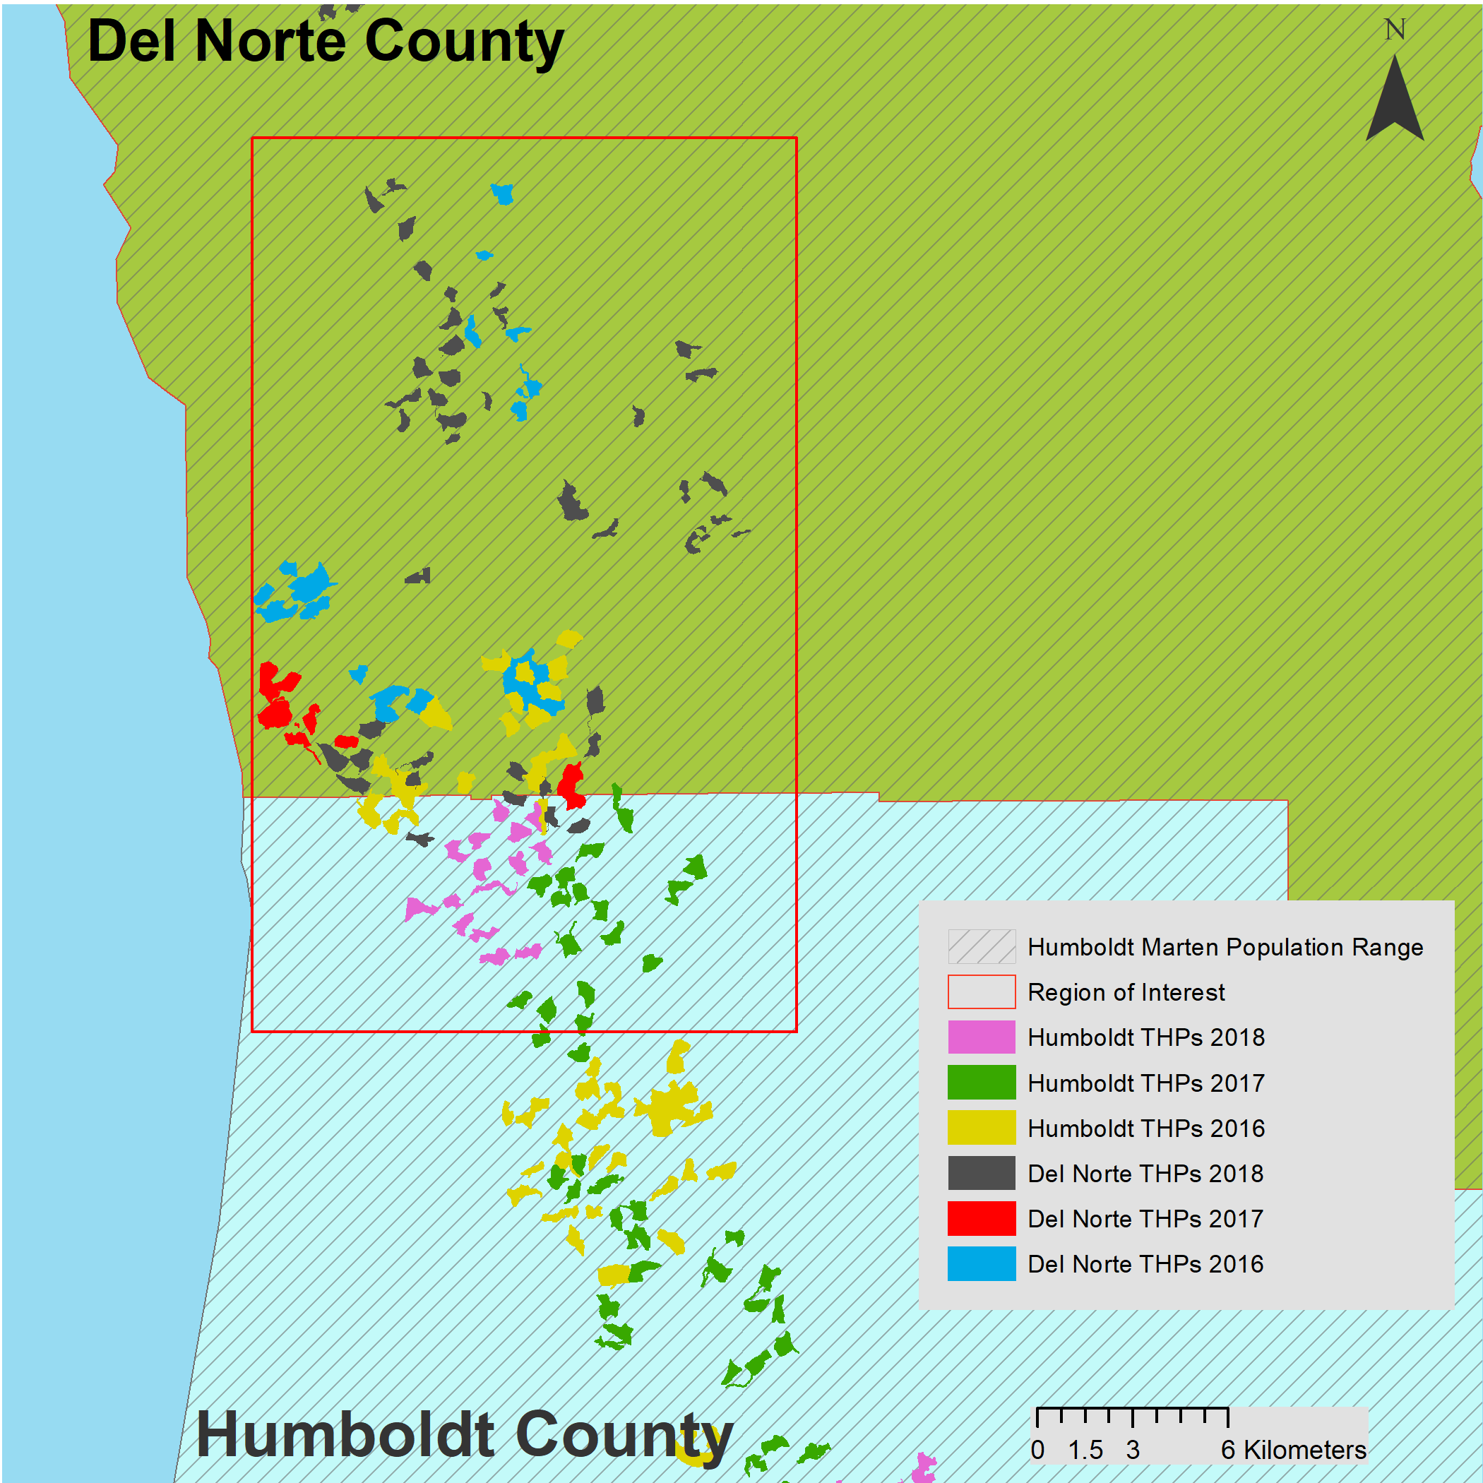

**Figure 1. Region of Interest Located in between Northern Humboldt County and Southern Del Norte County**

**Methods**

**To accomplish the goal of calculating the amount of timber harvested within this region of interest, I first gather datasets. I gather the recent timber harvest data within the last few years on the Calfire Website (egis.fire.ca.gov). Once this data gathered I then selected the years I wanted from the attribute table. I selected the years (2016-2018) for each individual data set including the Humboldt and Del Norte County. The following step in my data collection, is I gather Humboldt Marten population range shapefile from CalFire. By overlaying the old growth canopy cover type shapefile, located from USGS Gov I recognized which conifer and mixed conifer areas were harvested. I use the Geospatial Information System (GIS) to analyze the areas in which there is unlawful timber harvesting. GIS is a widely multiple disciplinary tools uses for analyzing the surface of the earth’s environment, using satellite imagery, and used for documenting changes over some time. GIS can be used to analyze the tree harvest from private industries and the areas they harvest. I can use the intersect tool in ArcMap 10.5 to intersect the layers and located what type of vegetation is being harvesting in the Humboldt Marten’s population range shown in Figures 3 and Figure 4. I used my cartographic skills to enhance the image and produce a map that can explain the areas where there is a threat to Marten’s population size. To enhance the final product, I added a Landsat 8 and DEM imagery and made a hillshade. In addition to the final product I labeled the county's upon EPIC’s request.**

**Table 1. Shows Data Sets, Description, and Source Locations**

|  |  |  |
| --- | --- | --- |
| **Data Set** | **Description** | **Source Locations** |
| **Timber Harvest Plans** | **Polygons of THPs (Timber Harvesting Plans status)** | **Cal Fire** |
| **Humboldt Marten Extended Population** | **Polygons of Martens Historical Home Range** | **Wedel, Ray at Cal Fire** |
| **Landsat 8** | **Raster Image used for categories purposes**  **-Hill shade**  **-Aspect** | **Landsat 8 USGS Earth Explorer** |
| **Canopy Cover Types** | **Polygons of Canopy Cover Types in California Forest** | **USGS Gov**  [**https://viewer.nationalmap.gov/basic/**](https://viewer.nationalmap.gov/basic/) |

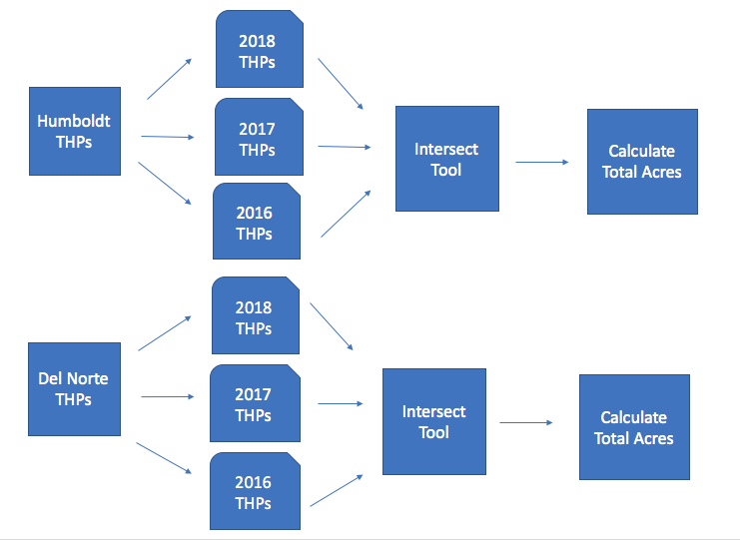

**Figure 2. Flow Chart of Work Flow**

**Results**

**I collected vegetation data within the Humboldt Marten Historical Population Area. In addition I gather Timber Harvest Plans in Humboldt and Del Norte county that intersect with the marten’s population range. Therefore according to EPIC they are unlawful harvest planes that remove important vegetation canopy types for the Humboldt Marten. As mentioned previously within this report, the Humboldt Marten relies on old growth population that contains conifer and mixed conifer cover type. The region analyzed is in Southern Del Norte County and Northern Humboldt County, near the Klamath River. This area is important for the Humboldt Marten Population range. According to Rob DiPera, this area is a highly dense populated area of Humboldt Marten, he states the Humboldt Marten was rediscovered in 1996 within this geographical region, prior to the rediscovered ecologist though this species was extinct. By doing this analysis on the humboldt marten and how much of their vegetation in their habitat area, the data can be used by EPIC to petition the Humboldt Marten as an endangered species under the Engaraged Species Act. In the area that was looked at private timber corporations harvest more mixed conifer tree species than strictly conifer species. From my analysis from 2016 to 2018 in both Humboldt and Del Norte county harvest a total of 38,032.49 acres of conifer cover type and a total of 70,351.33 of mixed conifer cover types shown in Table 2. When looking at the results my conclusions is that it makes economic sense why more mixed-conifer forest was harvest within this region. Mixed conifer canopy types included large pine trees that are smaller than strictly large conifer trees. According to the study area was dominated by tanoak (Notholithocarpus densiflorus) and Douglas fir forest associations, with other common tree species including bigleaf maple (Acer macrophyllum), golden chinquapin (Chrysolepis chrysophylla), Pacific madrone (Arbutus menzie- sii), Port Orford cedar (Chamaecyparis lawsoniana), red alder (Alnus rubra), sugar pine (Pinus lambertiana), and western hemlock (Tsuga heterophylla). (Delheimer, M. S., Slauson, K. M., Szykman Gunther, M., & Zielinski, W. J. (2018).)**

**It would be easier to navigate the material to harvest trees within a mixed conifer forest than strictly only dense conifer forest. However, the results of harvesting more mixed conifer forest could have severe impacts on the Humboldt marten population size. Because the marten is dependent on both cover types more research needs to be done which cover type they prefer.**

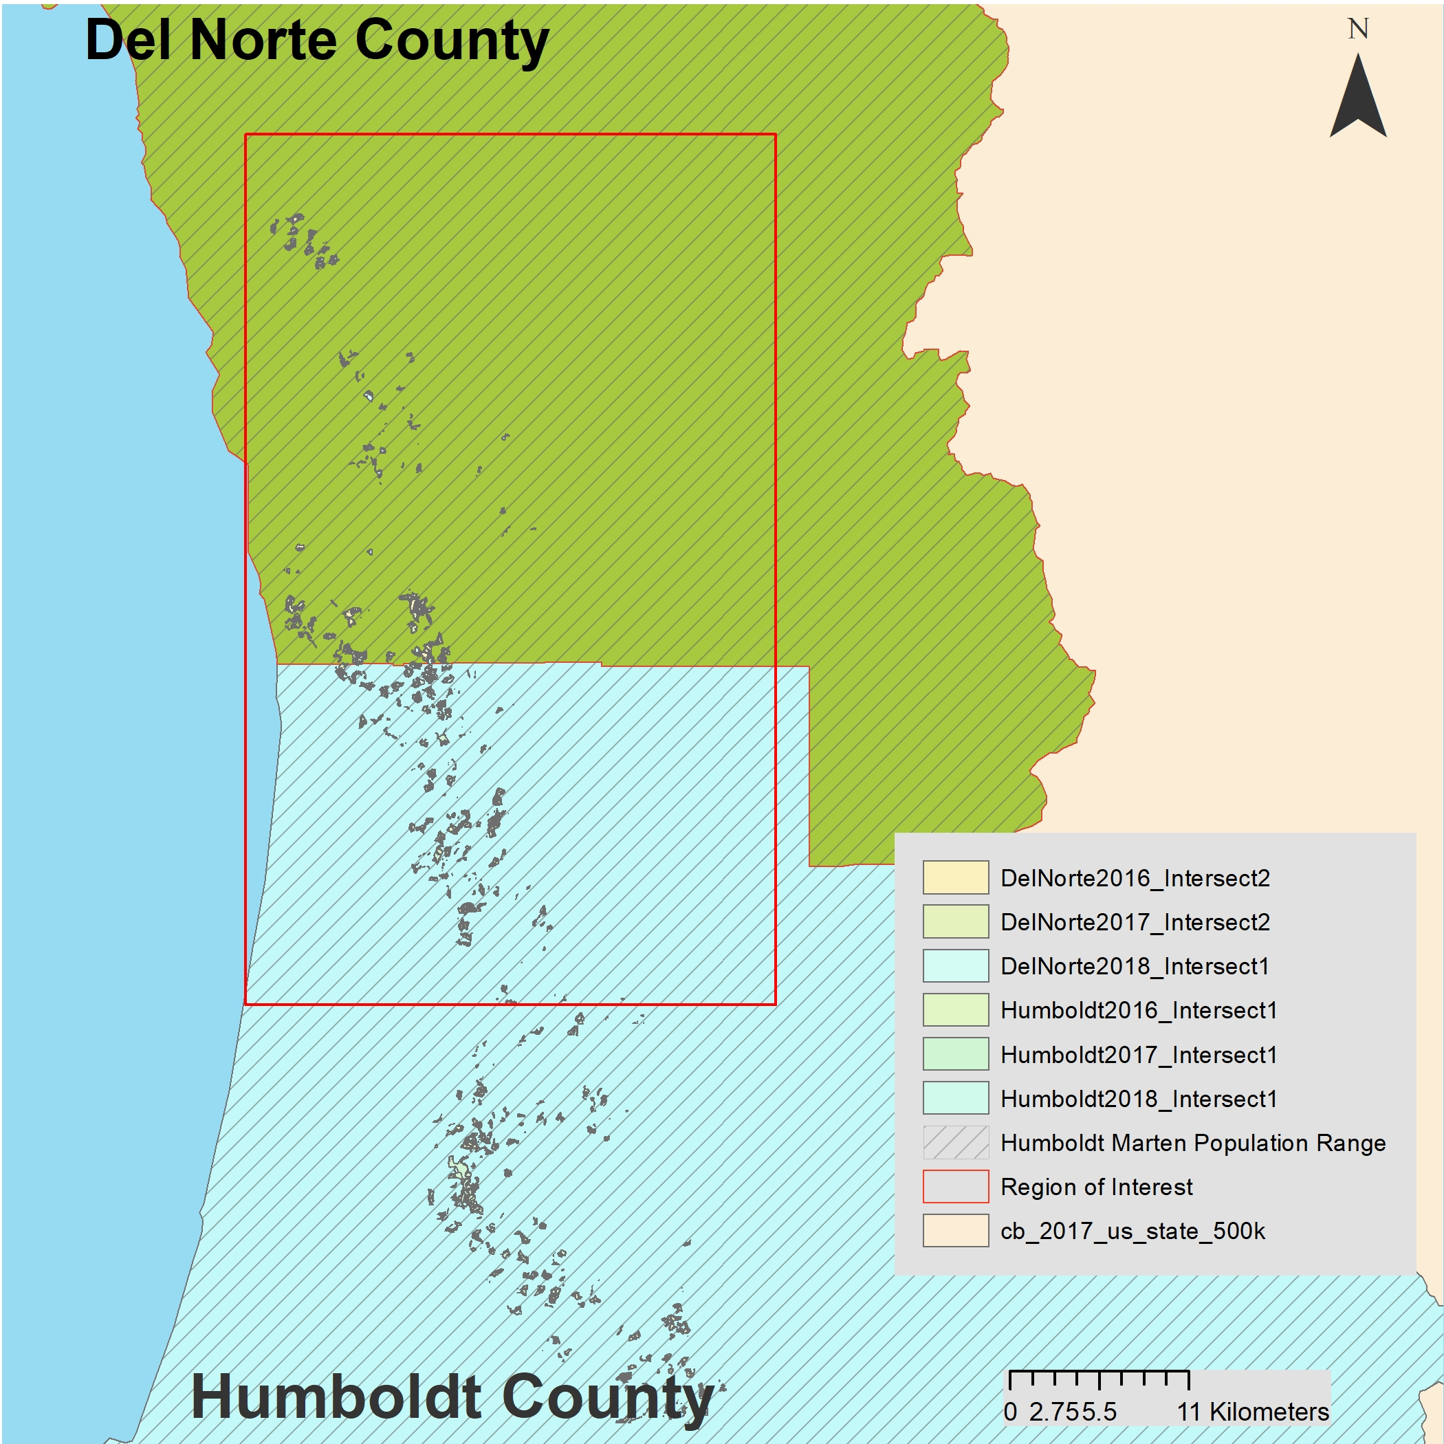

**Figure 3. Conifer Cover type**

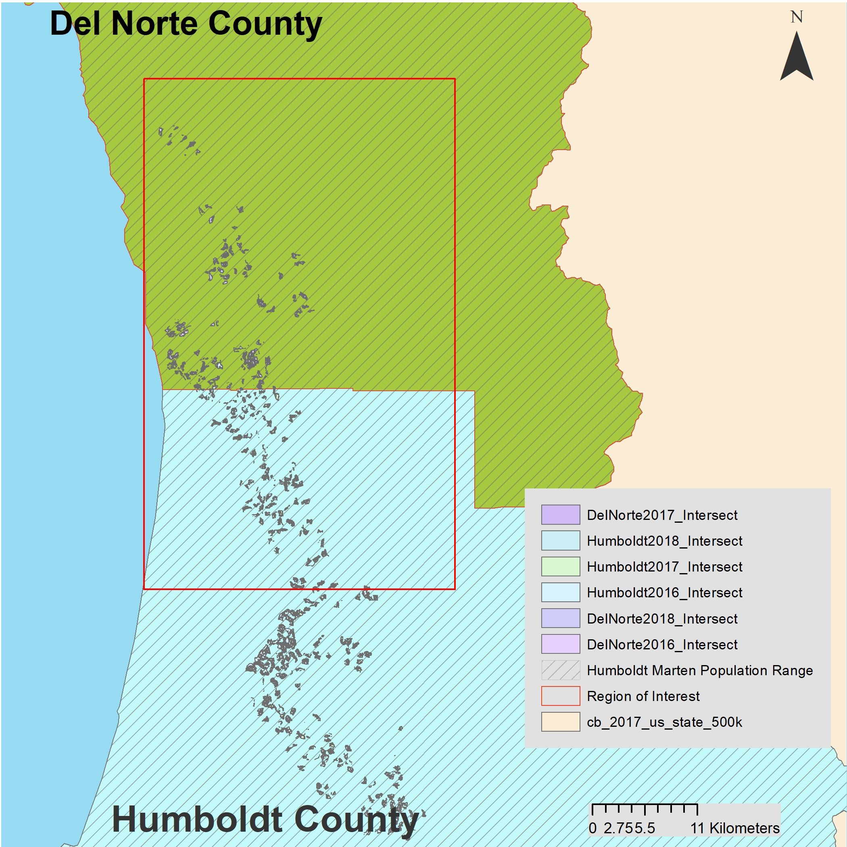

**Figure 4. Mixed Conifer Cover type**

**Tabel 2. Results of Intersection**

|  |  |  |
| --- | --- | --- |
| **TImber Harvest Plans** | **Conifer Covert type Intersection Acres** | **Mixed-Conifer Cover Type Intersection Acres** |
| **Humboldt THPs 2018** | **3,492.669** | **5,435.536** |
| **Humboldt THPs 2017** | **7,974.408** | **14,517.230** |
| **Humboldt THPs 2016** | **1,5209.999** | **2,4878.166** |
| **Del Norte THPs 2018** | **4,878.001** | **9,039.418** |
| **Del Norte THPs 2017** | **470.049** | **1,554.627** |
| **Del Norte THPs 2016** | **6,007.364** | **1,4926.348** |
| **Total Acres Harvested** | **38,032.49** | **70,351.33** |

**Figure Table comparing the Timber Harvest Plans for years 2016, 2017, 2018.**

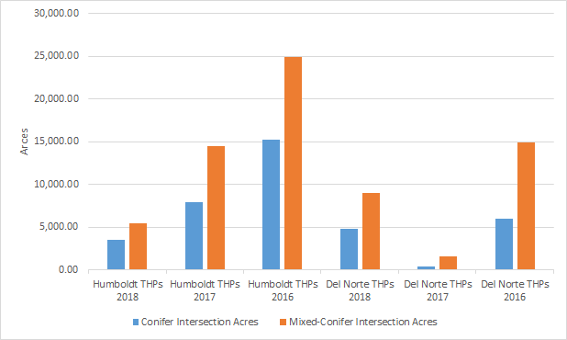

**Discussion**

**The Humboldt Marten is a species that is at risk of endangerment. The results of this short analysis of the type of vegetation covered harvested can help identify the areas were EPIC can focus on protecting. With this results shown in Figure 5. EPIC can focus on protecting in the red outlined areas. This analysis shows that the main private timber industry company is targeting more mixed conifer cover type to harvest. By protecting the Humboldt Marten it means to protect the mixed conifer forest. By showing hard evidence why the mixed old growth forest is important to martens, similar to how the northern spotted owl became protected, can help contribute the Humboldt Marten’s next species review. According to the Species Assessment for the Humboldt Marten, claims that the Humboldt Marten relies on mixed conifer and conifer forest located on the California Coast. For instance the report states, In summary, martens are closely associated with late-successional mesic coniferous forest with large diameter trees, logs, snags, and high overhead canopy closure. The historical distribution of Humboldt martens was closely tied to the coast redwood zone, an area characterized by summer fog. The extant population uses two fog-influenced forest types, open mixed conifer forests on serpentine soils and late-successional Douglas-fir forests on non-serpentine soils on the eastern edge of the coast redwood zone(Species Assessment for the Humboldt Marten (Hamlin, R., L. Roberts, G. Schmidt, K. Brubaker and R. Bosch 2010). This statement indicates that the mixed conifer forest type is very import for the Humboldt Marten Habitat population range. In addition this the results indicate more protection needs to be done within this area.There are some researchers in Oregon that are looking to show how the spotted owl and the Humboldt Marten have the same habitat. This this is true then, it shows evidence to protect both of this species that have the same habitat areas and population dispersal. According to “If the Humboldt martens occupy similar areas as northern spotted owls, then the current reserve allocation in Oregon may be adequate for retaining Humboldt marten populations”(Moriarty, K. M., Verschuyl, J., Kroll, A. J., Davis, R., Chapman, J., & Hollen, B) . By showing evidence how martens that have similar dependencies to old growth areas, and areas that are similar to the to the spotted owl natural habitat can greatly increase the chances of adding the Humboldt Marten as endangered species under the ESA.**

**Addition the results indicate**

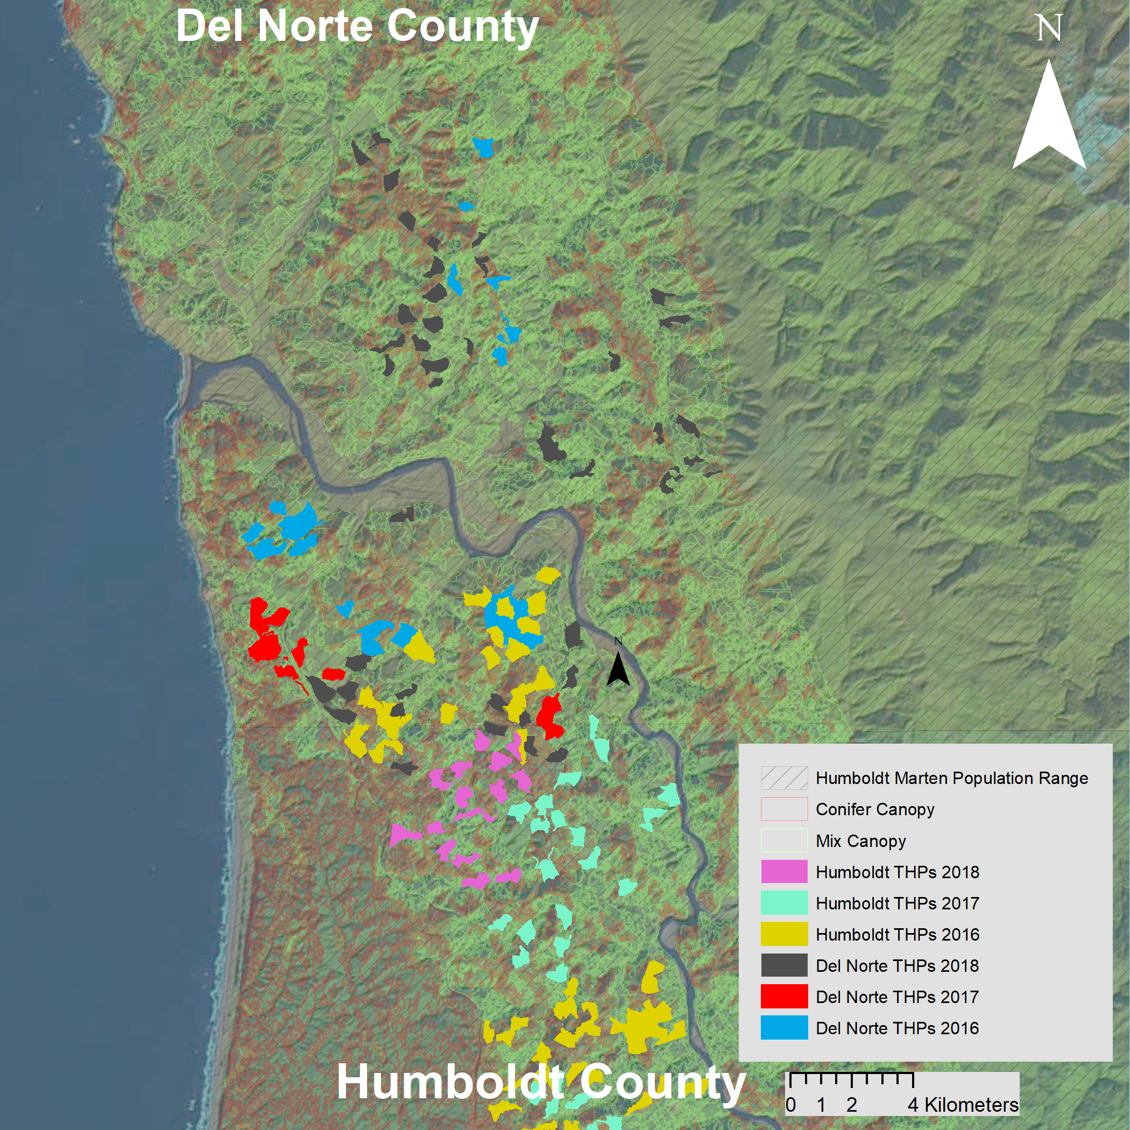

**Figure 5. Map of Timber Harvest Plans for Humboldt and Del Norte County that overlap with Humboldt Marten Population Range and Conifer and Mixed Canopy Forest**

* **Conclusion or Discussion (whichever works best for your project)**

**Acknowledgments**

**USGS Earth Explorer**

**USGS Gov**

**Wedel, Ray at Cal Fire**

**Cal Fire**

**References**

**Delheimer, M. S., Slauson, K. M., Szykman Gunther, M., & Zielinski, W. J. (2018). Use of artificial cavities by Humboldt marten. *Wildlife Society Bulletin*, *42*(3), 510–517.Retrieved February 26, 2019.**

**DiPerna, R. Personal Communication. February 15, 2019**

**Hutchinson, J. L., & Livingston, S. (2018). Species Status Assessment for the Coastal Marten (Martes caurina) Version 2.0. *Species Status Assessment for the Coastal Marten (Martes Caurina) Version 2.0,* *1*(2), 1-92. Retrieved February 15, 2019.**

**No Author. (2010). *Petition to List the Humboldt Marten (Martes americana humboldtensis)***

***as Threatened or Endangered under the Endangered Species Act. 1*(2), 1-42. Retrieved March 1, 2019.**

**Non author. (2015). *Notice of Receipt of the Petition.* Retrieved March 2, 2019.**

**Hamlin, R., L. Roberts, G. Schmidt, K. Brubaker and R. Bosch 2010. Species assessment for the Humboldt marten (Martes americana humboldtensis). U.S. Fish and Wildlife Service, Arcata Fish and Wildlife Office, Arcata, California. 34 + iv pp.**

**Moriarty, K. M., Verschuyl, J., Kroll, A. J., Davis, R., Chapman, J., & Hollen, B. (2019). Describing vegetation characteristics used by two rare forest-dwelling species: Will established reserves provide for coastal marten in Oregon? *PLoS ONE*, *14*(1), 1–25.** [**https://doi.org/10.1371/journal.pone.0210865**](https://doi.org/10.1371/journal.pone.0210865)